Dear Fresher,

Let’s begin with a huge congratulations to you for securing a place on the fantastic Cardiff University Optometry course! Most of you have probably not experienced anything like the next phase of your life before. Some of you may be quite hesitant and nervous about the big changes university brings, others may be itching to get here to join us all and enjoy Cardiff and all the excitement it brings! The aim of this letter is to let you know about the Optometry Society, OPSOC, run by Optometry students for Optometry students. We’ve all been through it and so with our great knowledge and experience we’re here to help with anything university life throws at you.

The main role of OPSOC is to get the Optometry students together and have a good time. We do our serious bit too, equipment fayres are held where you can buy your fancy new toys required for the course, ‘Cheese and Wine’ (“cough” pizza and beer...) evenings are held where optical suppliers, high street optical chains, and guest speakers come to talk to us about what they can offer us for equipment, pre-registration positions and career advice. We are now also running additional evening clinics to practice techniques under supervision from the more experienced 2nd and 3rd years. These will be based slightly closer to any practical exams that you have to ensure you have adequate help and support and make sure you’re well prepared.

We also do a lot for charity from bake sales, pancake days, world sight day challenges, Vision Aid Overseas and a pub quiz night supporting our returning vision charities in Moldova and Malawi. Last year we raised a massive £2000 for charity and this year we hope to improve on that already fantastic figure. These fantastic activities will be organized and run by our RAG(Raising and Giving) Reps and there are many ways to get involved with activities like these which will be explained in due course.

But wait there is more! OPSOC’s sport secretaries run loads of activities for students of all fitness levels and interest. Our netball teams train weekly and following increasing success in the university IMG league over the last four years and we now have 2 teams competing. OPSOC football team also competes in the University IMG league. This year we will be looking to increase our squad size, so guys… Get Involved! Everyone who attends training sessions will get to play in the matches they’re available for. The sports secretaries run weekly recreational badminton sessions for all abilities too. There really is something for everyone. We also try to get involved with other course based societies. For the last three years we have competed against Pharmacy in netball, football and badminton for the Boots Varsity Challenge Cup. Unfortunately we lost last year so let’s try and win it back this year!

For two years now we have held the very successful OPSOC House Cup, all in aide of charity with people competing for four different houses, Perkins, Jalie, Kanski and Elliott. There are a number of events some serious and some a bit silly across the day ranging from netball to old school sack races! It was a fantastic occasion where people had a real good laugh whilst also raising money for charity. We’re excited to build on the event this year with other chances to win points for you houses available. You will all find out what house you are in when you arrive in Freshers week!

Annually there is a big sports event between Optometry students from different universities called OPFEST. It is held at a different university every year and Cardiff held it last year and WON!! It’s not only a fun gathering between students from all institutions, it’s a chance to shine and show the other unis what we’re made of! There will be plenty of opportunity to get involved over the weekend from competing in the sport to volunteering across the weekend, and from experience, it is a fantastic way to meet other optometry students from across the country.

For the past eight years OPSOC has hosted its very own ski trip to Panticosa in the Pyrenees. As always we cater for all abilities from complete beginners to experienced skiers and snowboarders. We get the complete Pyrenean experience in Panticosa by sampling a different restaurant every evening and visiting a variety of bars and venues for evening entertainment. This trip is always considered one of the highlights of the year, and we will be making it a ninth year running because it’s just so popular! More details of this to follow in fresher’s week.

OPSOC hosts a brilliant array of social events. We have weekly events such as pub golf, other silly dress ups and quizzes and trips to activities such as bowling, the comedy club and ice skating, run each term. The biggest two events are our two annual balls, the Christmas ball at the end of term one and the eagerly awaited, themed Eye Ball at the end of term two. No expense is spared for this; the biggest, most anticipated event of the Cardiff Optometry calendar!
Past themes have included Arabian Nights (2010) with a live snake and belly dancing show, Nautical Chic (2011) with a surf simulator and Titanic shaped ice luge, Hollywood (2012), James Bond (2013) & Carnival (2014) with a 16 piece big band and flair bar tenders, a 1920s theme (2015) which showcased flapper dancing alongside themed casinos and most recently a Rio carnival to coincide with the Olympics this summer.

All the social events are organised by our social secretaries and they have a fantastic array of events for you in fresher’s week too! In your welcome pack there’s a time table showing you everything that’s going on in fresher’s week, make sure you attend all of these! The evening and weekend events are arranged by the social secretaries and are a fantastic way to get to know your classmates and students from other years too. The biggest event of fresher’s week is buddies night. This is where you meet your second and third year buddies who will help you make the transition into uni life as easily as possible. They’re your first port of call if you need any help throughout the year whether its work or lifestyle related. You’ll find out who your buddies are during fresher’s week and we’ll give you name tags to help you find each other on the night.

During the lead up to fresher’s week and the week itself the social secretaries are your go to people if any issues arise or you have any questions. If you can’t find them or have a question specific to another area (e.g. sports) the rest of the OPSOC team will be around to help you so please don’t hesitate to ask us. We’ve attached pictures of us all onto the last page of this letter so you know what we all look like and our roles.

Membership to OPSOC costs £30 (to be paid during fresher’s week), this gets you into cheese and wine evenings totally free which means loads of free pizza (non members pay £5 to attend these), free entry into the evening clinics (small charge to non members to cover costs), significantly discounted prices on OPSOC hoodies and tickets to social events such as the Christmas Ball and Eye Ball. It also gets you a free OPSOC membership card which gets you loads of discounts at the local pubs, bars, cafes and restaurants (see website for full listings). The membership fee is returned to you and then some in the huge savings you will make throughout the year in ticket purchases, cheese and wines, clinics and merchandise. It really is an incredibly valuable investment! Everything will be explained again when you get here freshers week!

Now, what do you need to do next? We know you’re all on Facebook these days so get online and log in. Search for the pages ‘Cardiff Optometry Freshers 2016/2017’ and ‘Cardiff OPSOC’. Now click ‘Join Group’. The first page is designed just for you lovely new first years to find out more about Optometry, OPSOC and each other before you get to Cardiff. We all met some of our now best friends for the first time this way and it will make those first few nervous days that little bit easier. Every member of the OPSOC committee is a member of this group so please feel free to add any of us as a friend if you have any questions about socials, halls, what to bring or anything like that. The second page is the page for all three years (and some staff!). The Cardiff OPSOC Facebook page is where all the news, updates and all important event invitations come from, you need to join this one to be clued up on everything that’s going to be happening over the next three years. These are the best places to get in touch with us, and a good way to get in touch with each other so you can start the fun as soon as you get to Cardiff! Cardiff OPSOC is on twitter so follow us or tweet us to let us know you’re coming.

So, congratulations again and good luck with your move to Cardiff, we’re sure you will love it as much as we do and are very excited to meet you all! We’ll be around in fresher’s week if you need any information and some of us before, so if you need us... head to FACEBOOK or FACEBOOK message myself or Alex!

Looking forward to seeing you soon!

Patrick Foley (President) & Alex Thornton (Vice President)

THE COMMITTEE

President - Patrick Foley Vice President – Alex Thornton Treasurer – Ankit Patel
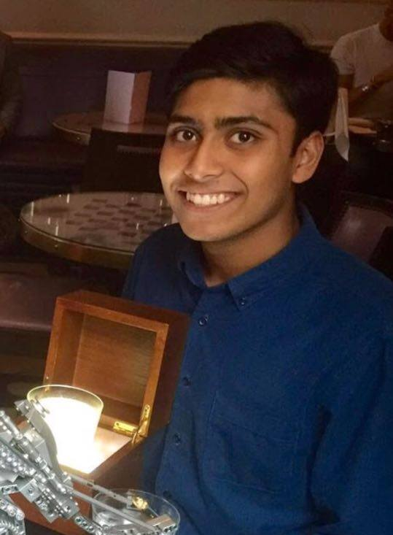

Social Secretaries Sports Secretaries
Ffion Jones & Mari Jones Wrayon Vassel & Beth Hughes

General Secretaries Rag Reps
Oscar Tully & Amber Stelling Hannah Jones & Ellie Williams

